CHRISTMAS DINNER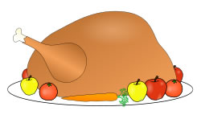
THURSDAY, DECEMBER 3RD, 2015
Turkey, Stuffing, Potatoes, Cranberry Sauce, Carrots, Corn, Milk, and dessert (Choice of Apple Crisp or Cheesecake) - Cost $5.95
All orders and money must be handed back to homeroom teachers by Wednesday, November 25th.
STUDENTS NAME: ____________________
HOMEROOM: _________________________
CHOICE OF DESSERT __________________

CHRISTMAS DINNER
THURSDAY, DECEMBER 3RD, 2015
Turkey, Stuffing, Potatoes, Cranberry Sauce, Carrots, Corn, Milk, and dessert (Choice of Apple Crisp or Cheesecake) - Cost $5.95
All orders and money must be handed back to homeroom teachers by Wednesday, November 25th.
STUDENTS NAME: ____________________
HOMEROOM: _________________________
CHOICE OF DESSERT __________________

